**ביקור השר לשתפ"א והממונה על החברות הממשלתיות**

**דויד אמסלם**

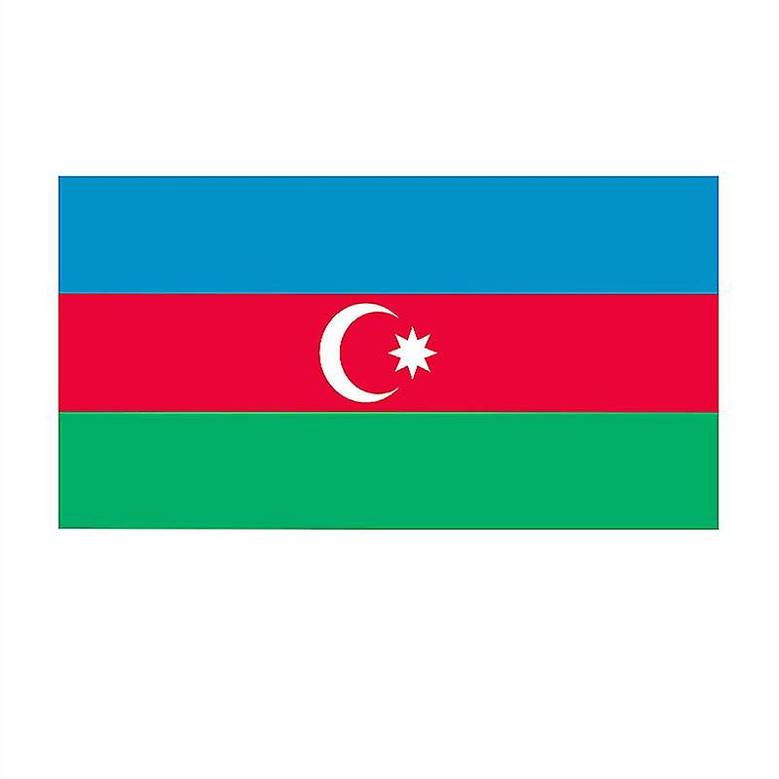**14-18.7**.**2024**

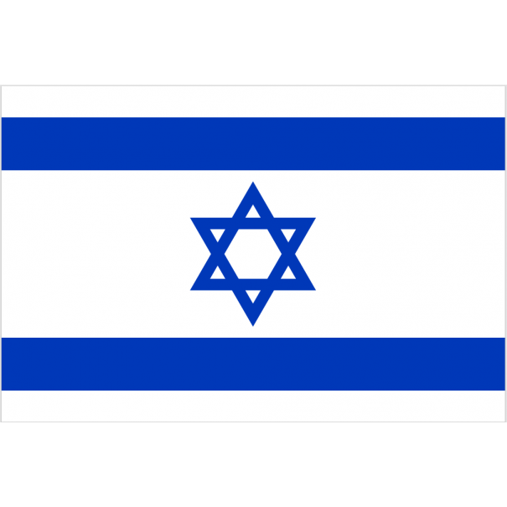

**Schedule**

Sunday 14.07.2024

| **הערות** | **Participants** | **Location** | **Meeting** | **Time** |  |
| --- | --- | --- | --- | --- | --- |
|  | **Ambassador**   * **Protocol (TBC)** | Airport  GYD- (Geydar Aliyev International) | Landing in Baku  J322 | 16:30 |  |
|  |  |  | Transport to Hotel “Four Seasons” | 17:00-17:30 |  |
|  |  |  | Free time | 17:30- 18:30 |  |
|  |  | **TBC** | Departure to Restaurant | 18:30 |  |
|  |  | **TBC** | Dinner and briefing with the Ambassador, the minister and his staff | 18:30 – 21:00 |  |

Monday 15.7.2024

|  |  |  |  |  |  |
| --- | --- | --- | --- | --- | --- |
| **הערות** | **Participants** | **Location** | **Meeting** | **Time** |  |
|  |  |  | Hotel breakfast |  |  |
|  |  | TBC | Briefing meeting with the Minister, the ambassador and the entire delegation | 09:00-09:30 |  |
|  | (the whole delegation) Please arrange vehicles accordingly |  | Departure to the Ministry of Economy | 09:30 -10:00 |  |
|  |  |  | Tete a tete- meeting between the Ministers | 10:00-10:15 |  |
| Meeting between the delegations in the Ministry of Economy All delegation members and Representatives of the energy sector from Israel |  |  | Working meeting with Minister of Economy Mikail Jabbarov. | 10:30 – 12:00 |  |
|  |  |  | Departure to visit the Cyber Center of the Technion – the whole delegation | 12:00 – 12:30 |  |
|  |  | Tour of the center lunch at the offices | 12:30-14:00 |  |
|  |  | Departure to the Water Agency | 14:00 |  |
| Mr, Amit Lang, CEO of Mekorot, Former CEO of the Ministry of Economy |  |  | Meeting with the National Water Authority Zaur Mikaylov | 14:30- 15:30 |  |
| להזמין זר |  |  | Departure to Avenue of the Fallen- whole delegation | 15:30-16:00 |  |
| whole delegation |  |  | Wreath-laying ceremony on the Avenue of the Fallen- | 16:00 -16:15 |  |
| whole delegation |  |  | Departure to the Ashkenazi Jewish Community | 16:15-16:45 |  |
| - whole delegation |  |  | Meeting with the Rabbis of the communities, the chairman of the Ashkenazi community, Rabbi Shneor, the chairman of the mountain community, and Rabbi Zamir | 16:45-18:00 |  |
|  |  |  | Departure to Hotel | 18:00-18:15 |  |
|  |  |  | Free Time | 18:15-19:15 |  |
|  |  | TBC | Departure to Restaurant | 19:15 |  |
|  |  |  | Formal dinner (OPTIONAL) | 19:30-22:00 |  |

Tuesday 16.07.2024

|  |  |  |  |  |
| --- | --- | --- | --- | --- |
| **הערות** | **Participants** | **Location** | **Meeting** | **Time** |
|  |  |  | Hotel breakfast |  |
|  |  |  | Departure to Baku port | 08:15 |
|  | Dr. Yuval Steinitz, Chairman of “Rafael”. Yoav Turgeman, CEO Rafael. Mr. Boaz Levy CEO of Rafael. Mr. Shimon Heineman, Regional head of sales of Rafael. Mr. Arnon Baram, CEO of Magal Systems (member of Rafael Group) |  | Tour of the port of Baku + meeting with the chairman of the port. | 09:15-10:30 |
|  |  |  | Departure TO the Ministry of Energy | 10:30-11:30 |
|  | Dr. Yuval Steinitz, Chairman of “Rafael”. Efi, Chief of staff of Dr. Yuval Steinitz, Chairman |  | Meeting with the Minister of Energy. | 11:30-12:30 |
|  |  |  | Departure for SOCAR +Lunch | 12:30-13:30 |
|  | Participants: Dr. Yuval Steinitz, Chairman of “Rafael”, Efi, Chief of staff of Dr. Yuval Steinitz. Mr. Arnon Baram, CEO of Magal Systems (member of Rafael Group). |  | Meeting with the president of SOCAR Rovshan Najaf (who is under the office of Minister Jubarov) and a light lunch. Socar's partners in Israel | 14:00-15:00 |
|  |  |  | Departure for a Ministry of Transport | 15:00-15:30 |
|  | Mr. Arnon Baram, CEO of Magal Systems (member of Rafael Group) |  | meeting with the Minister of Transport and the chairman of the CAA and the President of the national airlines  Head of civil aviation Authority Arif Mammedov, Samir Rzaev, President of Azerbaijan Airlines, Zaur Akhundov, President of Silkway | 15:30-16:30 |
|  |  |  | Tour of old city + dinner | 17:00-22:00 |

Wednesday 17.07.2024

|  | **Participants** | **Location** | **Meeting** | **Time** |  |
| --- | --- | --- | --- | --- | --- |
|  |  |  | Hotel breakfast |  |  |
|  |  |  | Departure to the Ministry of Defense | 08:45 |  |
|  | Dr. Yuval Steinitz, Chairman of Rafael, Former Minister of Finance, Former Chairman of the Foreign Affairs and Defense Committee, Former Minister of Agriculture and a senior member of the Defense Political Cabinet. Yoav Turgeman, CEO Rafael .Mr. Boaz Levy CEO of Rafael .Mr. Shimon Heineman, Regional head of sales of Rafael.Mr. Arnon Baram, CEO of Magal Systems (member of Rafael Group) Mr. Amir Peretz, Chairman of IAI (Israeli Aerospace Industries), former Minister of Defense, former Chairman of the Israeli Labor Union .Mr. Moshe Hanuka, Chief of staff of IAI |  | Meeting with the Minister of Defense Zakir Hasanov and the CEO of his office Agil Gurbanov. | 09:00-10:00 |  |
|  |  |  | Departure Border Protection Service | 10:15-10:30 |  |
|  | Dr. Yuval Steinitz, Chairman of Rafael, Former Minister of Finance, Former Chairman of the Foreign Affairs and Defense Committee, Former Minister of Agriculture and a senior member of the Defense Political Cabinet. Yoav Turgeman, CEO Rafael .Mr. Boaz Levy CEO of Rafael .Mr. Shimon Heineman, Regional head of sales of Rafael.Mr. Arnon Baram, CEO of Magal Systems (member of Rafael Group) Mr. Amir Peretz, Chairman of IAI (Israeli Aerospace Industries), former Minister of Defense, former Chairman of the Israeli Labor Union .Mr. Moshe Hanuka, Chief of staff of IAI |  | Meeting with the Minister of Border Protection Alchin Guliev | 10:30-11:30 |  |
|  |  |  | Departure for a meeting in the President's office | 11:45-12:00 |  |
|  | Dr. Yuval Steinitz, Chairman of Rafael,. Yoav Turgeman, CEO Rafael. Mr. Boaz Levy CEO of Rafael. Mr. Shimon Heineman, Regional head of sales of Rafael.Mr. Arnon Baram, CEO of Magal Systems (member of Rafael Group) Mr. Amir Peretz, Chairman of IAI (Israeli Aerospace Industries), former Minister of Defense, former Chairman of the Israeli Labor Union. Mr. Moshe Hanuka, Chief of staff of IAI |  | Meeting with Andrei Sipilin, adviser to the President and member of the cabinet and responsible on behalf of the president for supporting the military department. | 12:00-13:00 |  |
|  |  |  | Lunch | 13:00-13:30 |  |
|  | We arrive in Quba- whole delegation |  | Departure for Quba | 13:30- 15:30 |  |
|  |  |  | Tour of the community, synagogues, museum | 15:30- 17:00 |  |
|  |  |  | Dinner and closing of the visit with the leaders of the Jewish community and the governor | 17:00-19:30 |  |
|  |  |  | |  | | --- | | Departure back to the hotel to Baku | | 19:30- 21:30 |  |

Thursday 18.07.2024

| **הערות** | **Participants** | **Location** | **Meeting** | **Time** |  |
| --- | --- | --- | --- | --- | --- |
| **שגריר מלווה** |  | Airport  GYD- (Geydar Aliyev International) | Departure for the airport | 07:00 |  |
|  |  |  | Take off back to Israel **J321** | 09:00 |  |